sudo yum update -y

in the amazon linux enter the above command and hit enter to update yum

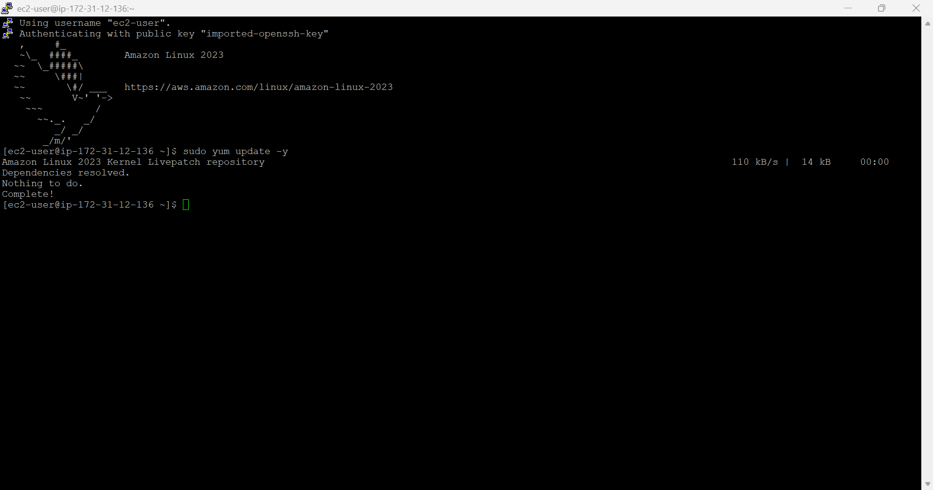

sudo yum install -y java-11-amazon-corretto

install java 11 by using above command

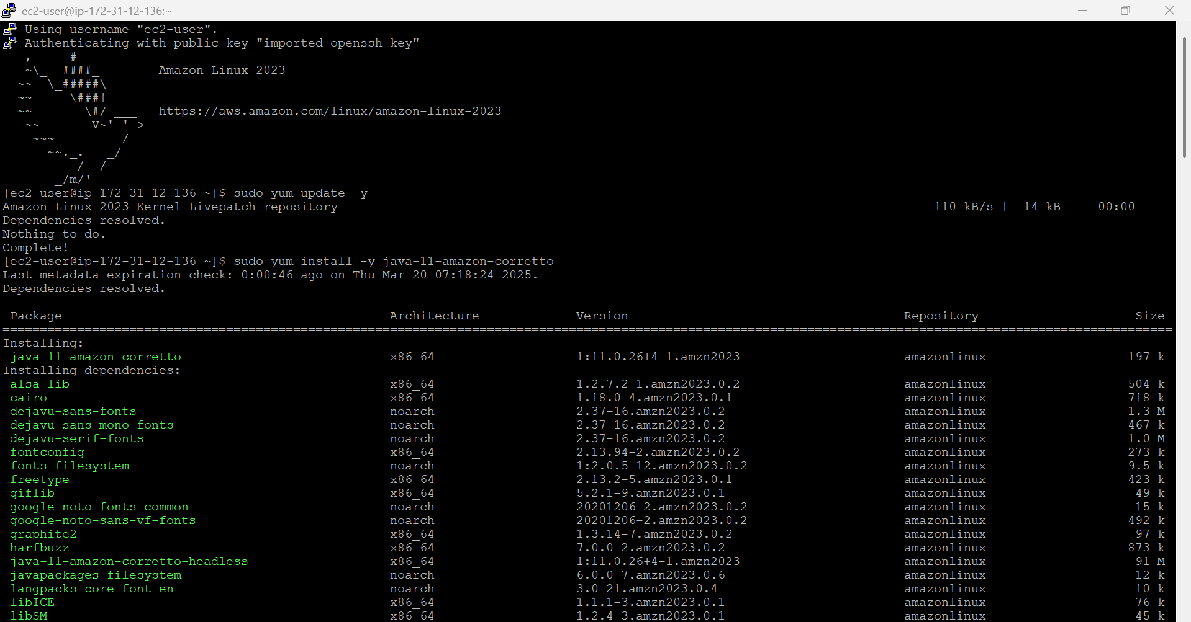

java -version

check java version to know java installed or not

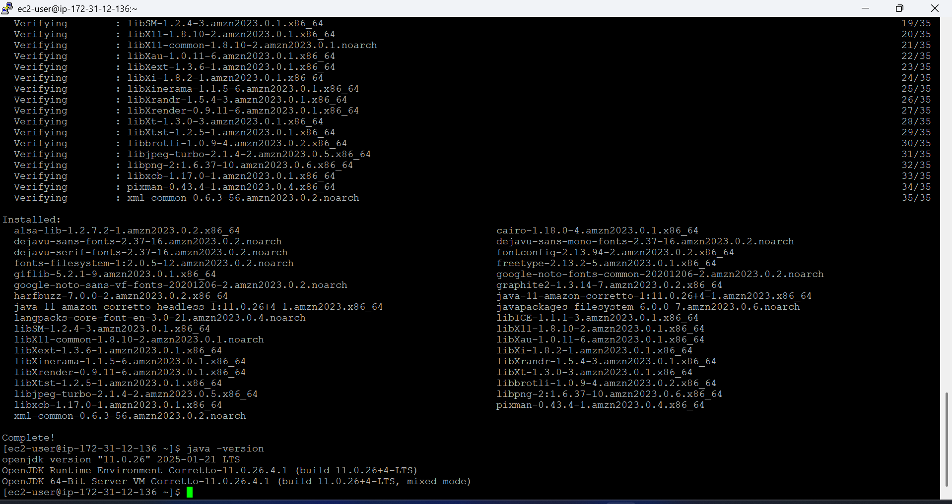

sudo yum install -y maven

Install the maven

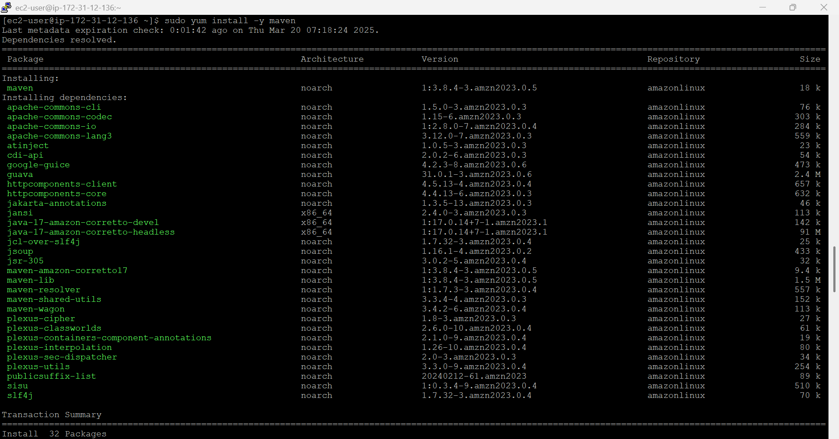

mvn -version

check maven version

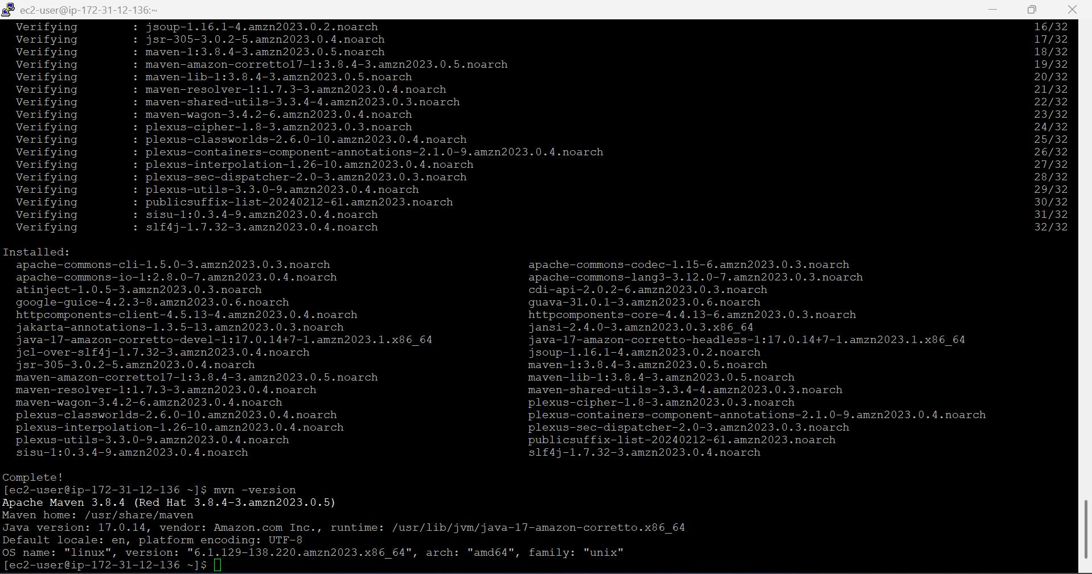

sudo nano /etc/profile.d/maven.sh

configure maven

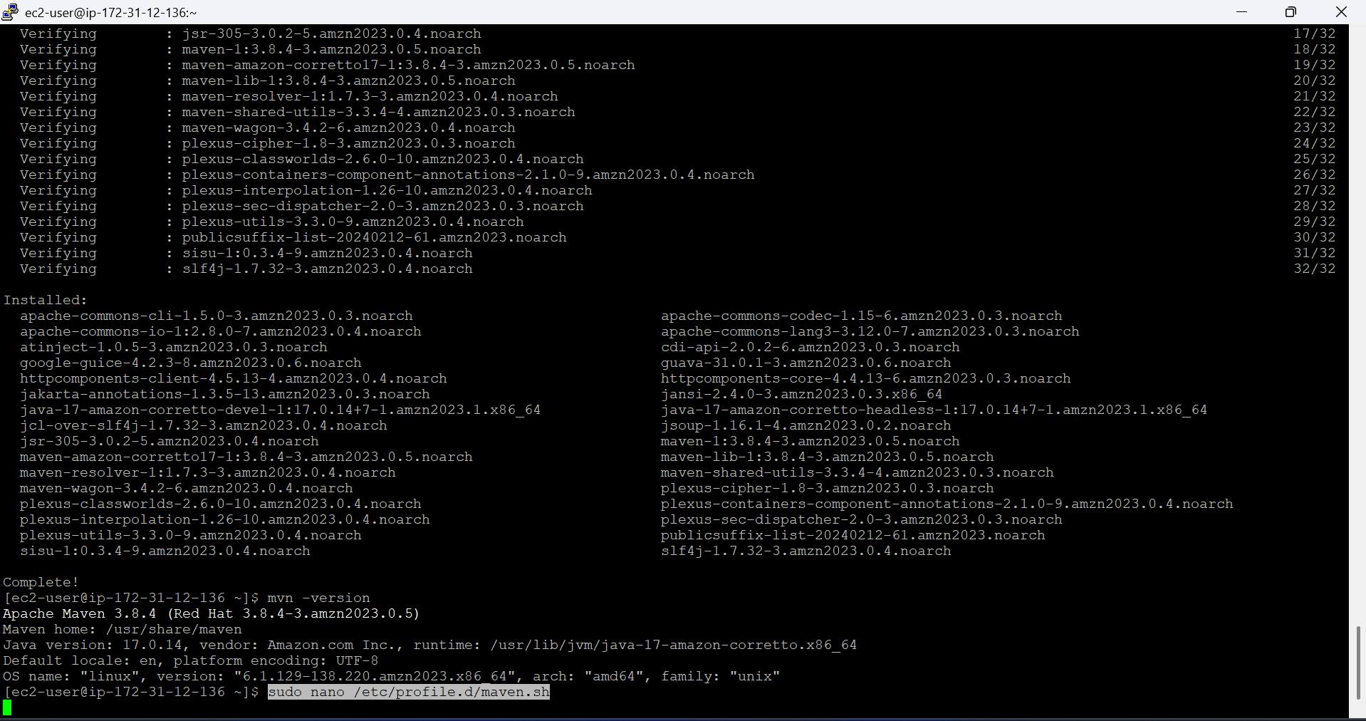

export M2_HOME=/usr/share/maven

export PATH=$M2_HOME/bin:$PATH

paste above lines

to save and exit (CTRL + X, then Y, then Enter)

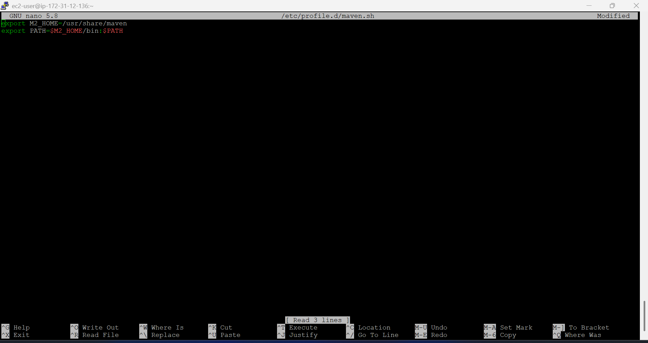

source /etc/profile.d/maven.sh

apply the changes

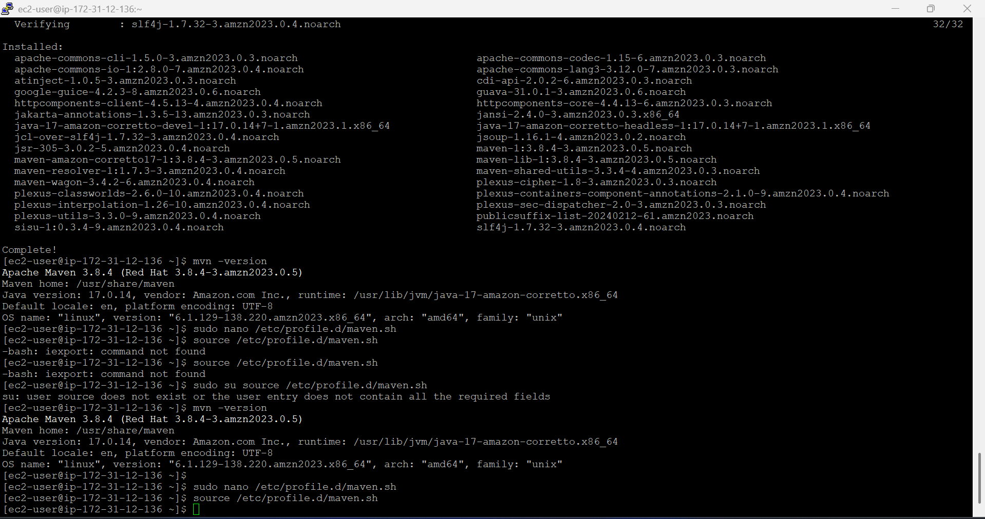

mvn -version

verify again

